Test Case: tc001_SPX_Dev5_Crear_Nueva_Linea_Requisicion_Spot_Tipo_Cobro_CC
Step 1 - Enter username and password and click to button Enter : Credentials Entered
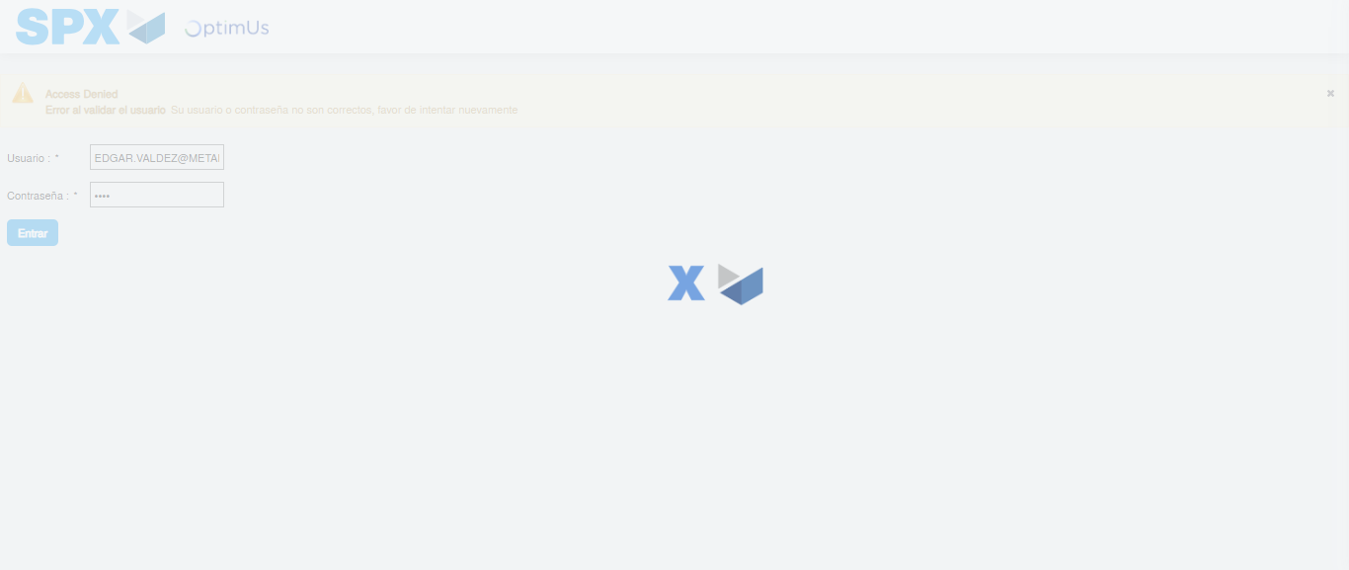Image file-name: QC_Testing-tc001_SPX_Dev5_Crear_Nueva_Linea_Requisicion_Spot_Tipo_Cobro_CC-1781315449711

Step 2 - Select to UEN and Access to Spot Buy Requisitions : UEN Correctly selected and Correct access
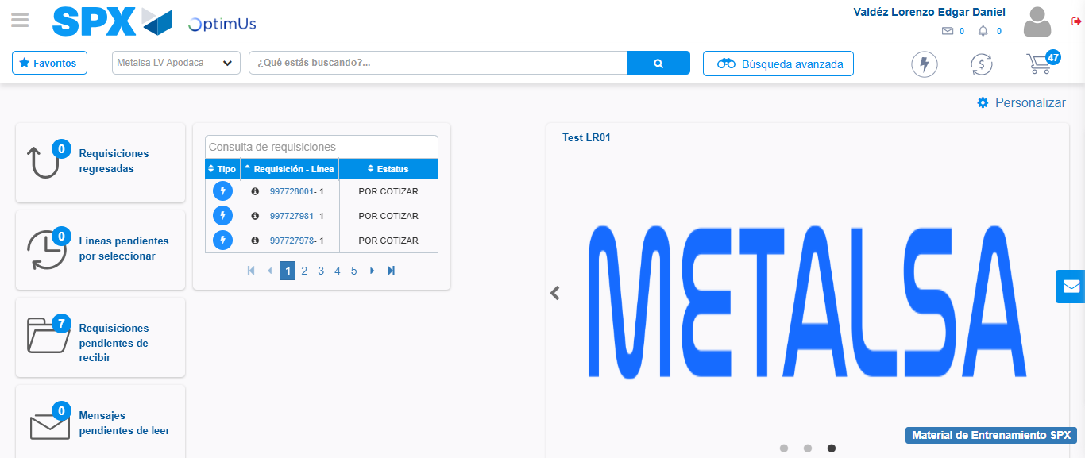Image file-name: QC_Testing-tc001_SPX_Dev5_Crear_Nueva_Linea_Requisicion_Spot_Tipo_Cobro_CC-1781315475385

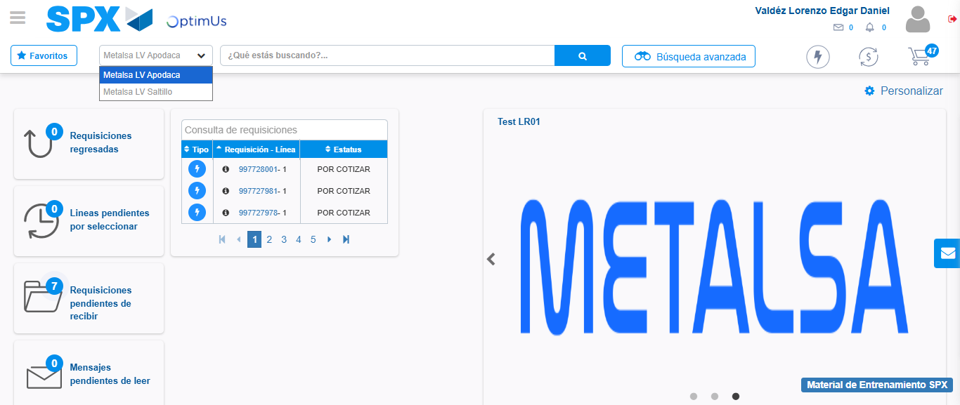Image file-name: QC_Testing-tc001_SPX_Dev5_Crear_Nueva_Linea_Requisicion_Spot_Tipo_Cobro_CC-1781315477936

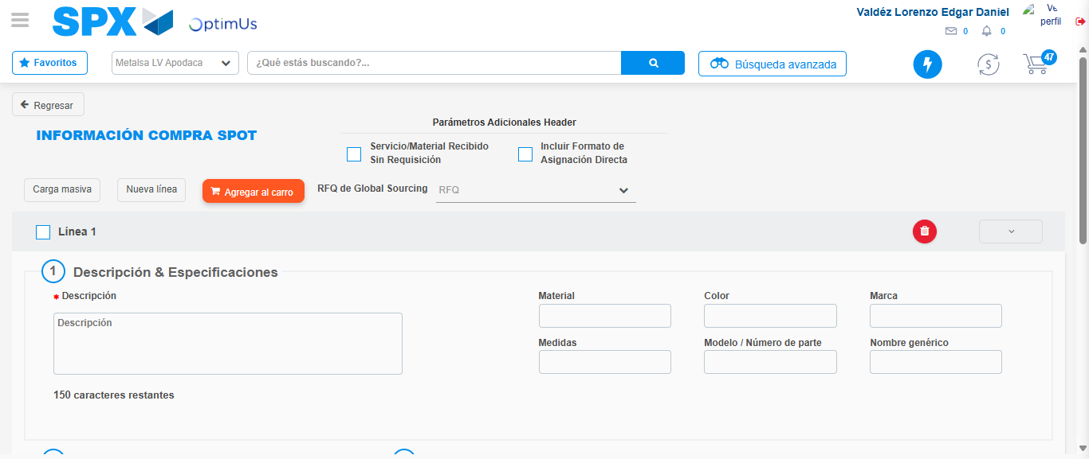Image file-name: QC_Testing-tc001_SPX_Dev5_Crear_Nueva_Linea_Requisicion_Spot_Tipo_Cobro_CC-1781315500756

Step 3 - Data Capture Spot Buy Requisition: Data captured correctly
Image file-name: QC_Testing-tc001_SPX_Dev5_Crear_Nueva_Linea_Requisicion_Spot_Tipo_Cobro_CC-1781315500976

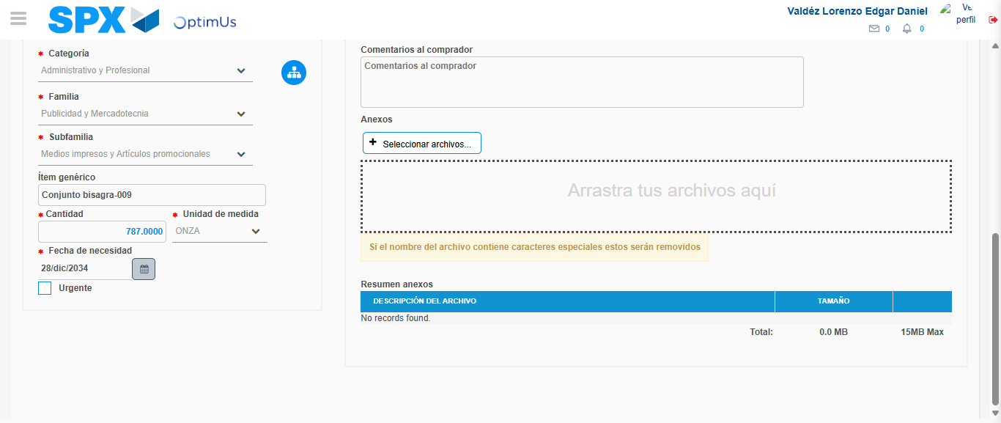Image file-name: QC_Testing-tc001_SPX_Dev5_Crear_Nueva_Linea_Requisicion_Spot_Tipo_Cobro_CC-1781315512637

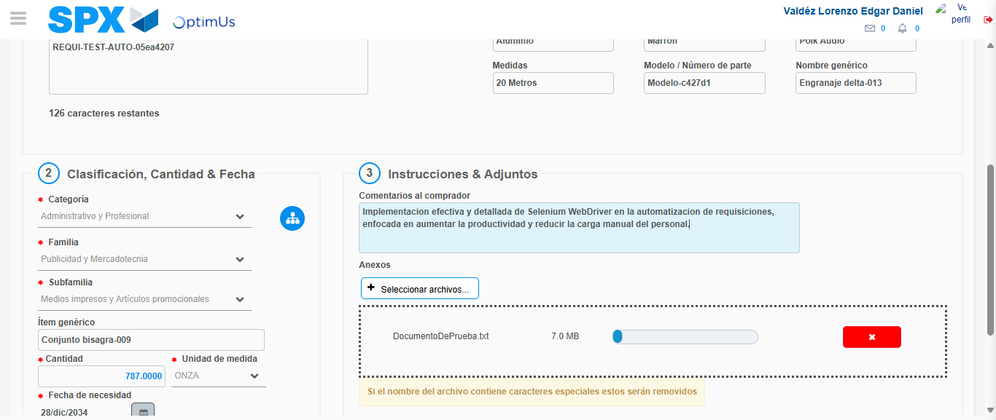Image file-name: QC_Testing-tc001_SPX_Dev5_Crear_Nueva_Linea_Requisicion_Spot_Tipo_Cobro_CC-1781315513490

Step 4 - Add new line and data capture second line: Line add correctly
Image file-name: QC_Testing-tc001_SPX_Dev5_Crear_Nueva_Linea_Requisicion_Spot_Tipo_Cobro_CC-1781315500976

Image file-name: QC_Testing-tc001_SPX_Dev5_Crear_Nueva_Linea_Requisicion_Spot_Tipo_Cobro_CC-1781315512637

Image file-name: QC_Testing-tc001_SPX_Dev5_Crear_Nueva_Linea_Requisicion_Spot_Tipo_Cobro_CC-1781315513490

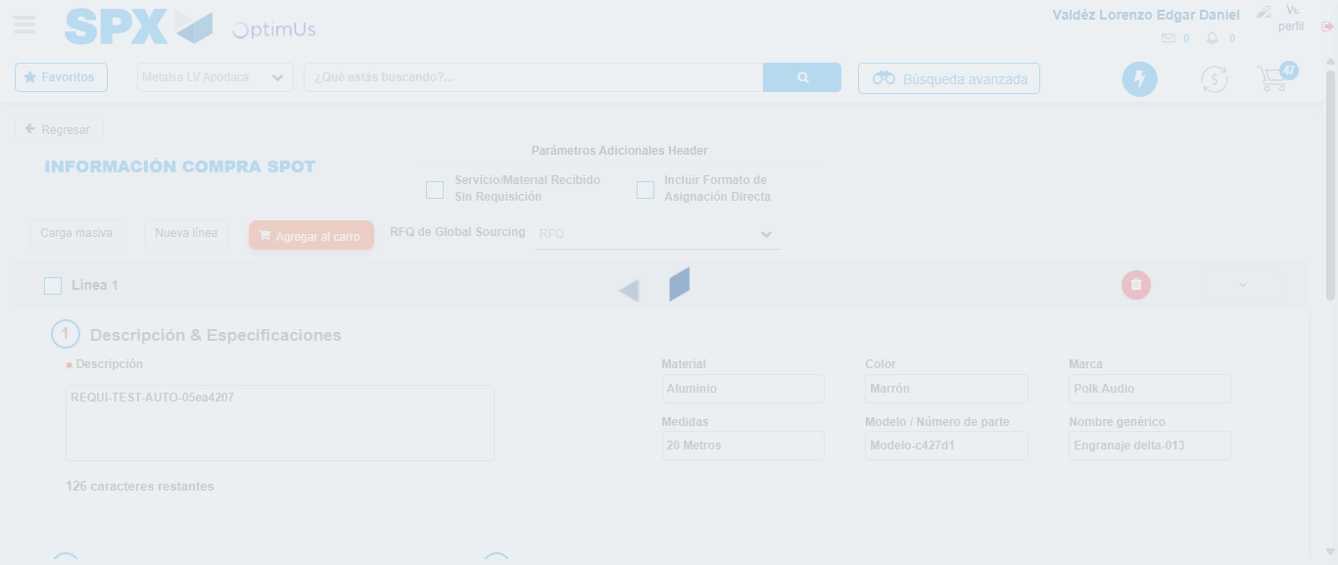Image file-name: QC_Testing-tc001_SPX_Dev5_Crear_Nueva_Linea_Requisicion_Spot_Tipo_Cobro_CC-1781315515802

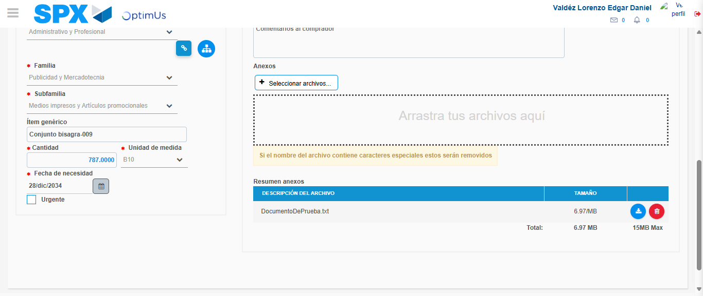Image file-name: QC_Testing-tc001_SPX_Dev5_Crear_Nueva_Linea_Requisicion_Spot_Tipo_Cobro_CC-1781315527230

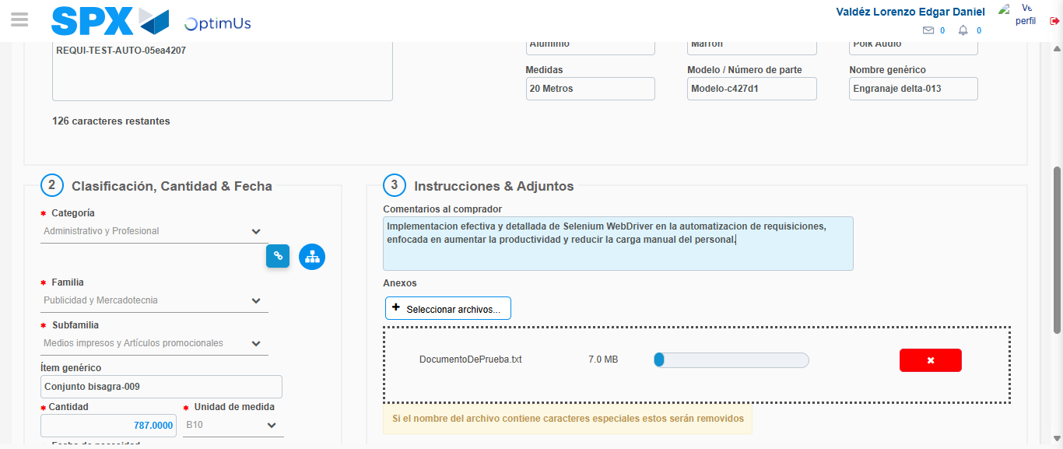Image file-name: QC_Testing-tc001_SPX_Dev5_Crear_Nueva_Linea_Requisicion_Spot_Tipo_Cobro_CC-1781315528052

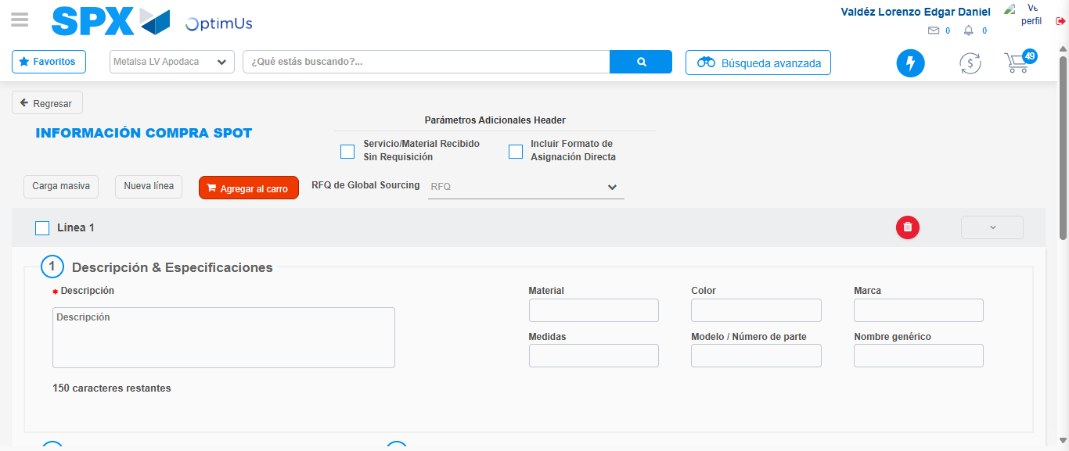Image file-name: QC_Testing-tc001_SPX_Dev5_Crear_Nueva_Linea_Requisicion_Spot_Tipo_Cobro_CC-1781315535714

Step 5 - Select to Requisition: Requisition Correctly selected
Image file-name: QC_Testing-tc001_SPX_Dev5_Crear_Nueva_Linea_Requisicion_Spot_Tipo_Cobro_CC-1781315535900

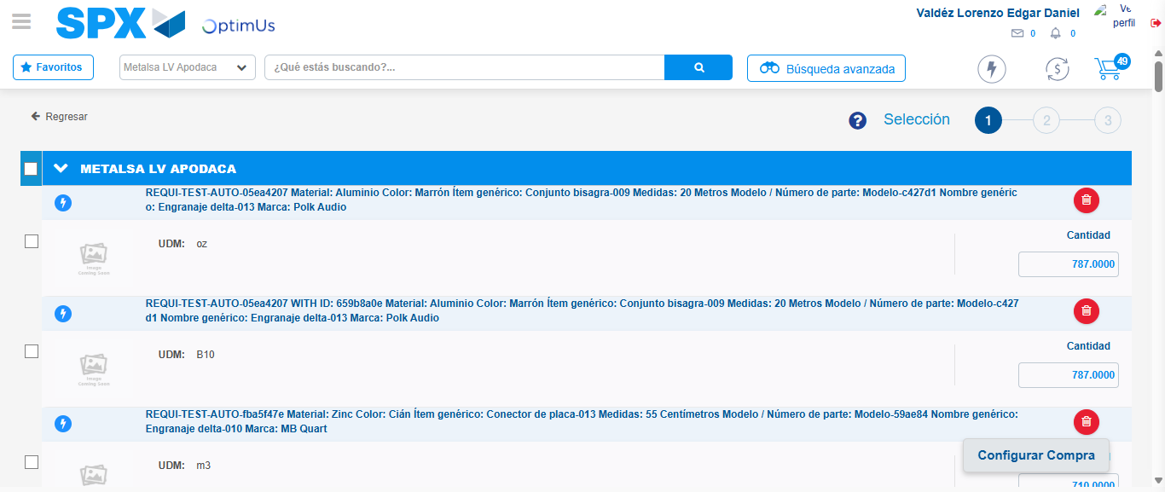Image file-name: QC_Testing-tc001_SPX_Dev5_Crear_Nueva_Linea_Requisicion_Spot_Tipo_Cobro_CC-1781315541522

Image file-name: QC_Testing-tc001_SPX_Dev5_Crear_Nueva_Linea_Requisicion_Spot_Tipo_Cobro_CC-1781315541734

Image file-name: QC_Testing-tc001_SPX_Dev5_Crear_Nueva_Linea_Requisicion_Spot_Tipo_Cobro_CC-1781315541894

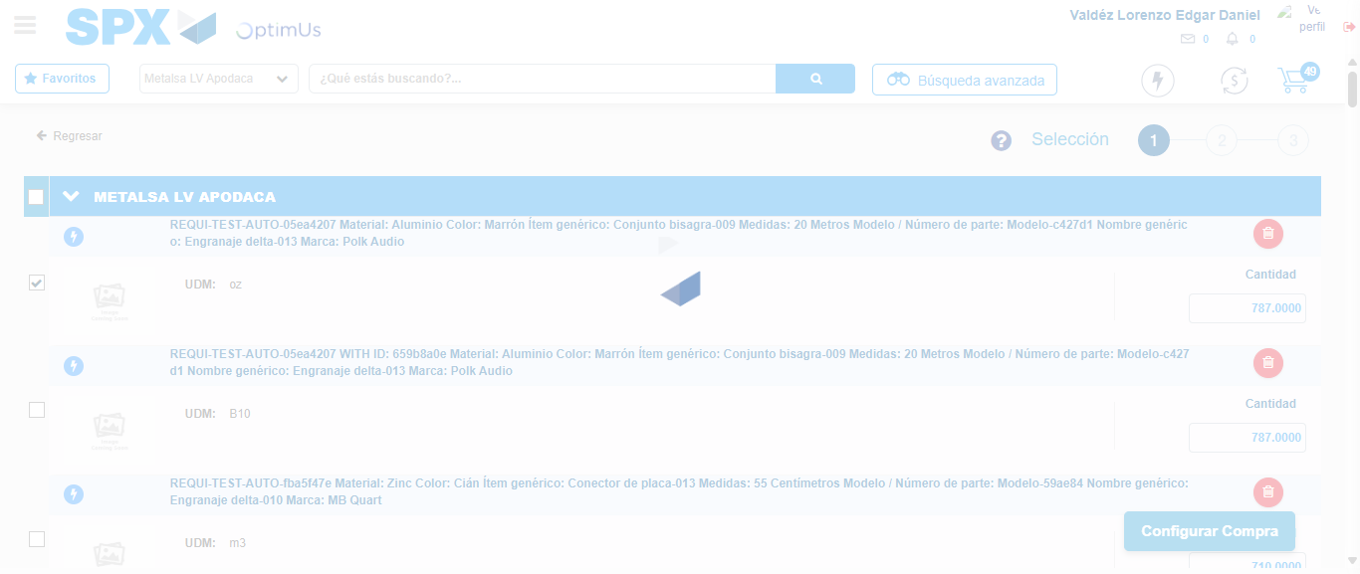Image file-name: QC_Testing-tc001_SPX_Dev5_Crear_Nueva_Linea_Requisicion_Spot_Tipo_Cobro_CC-1781315542794

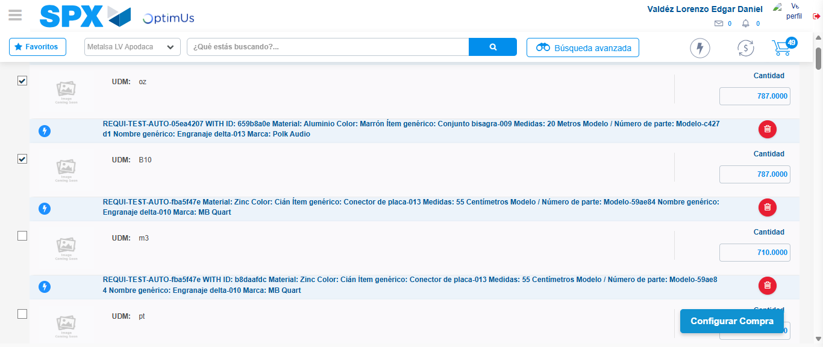Image file-name: QC_Testing-tc001_SPX_Dev5_Crear_Nueva_Linea_Requisicion_Spot_Tipo_Cobro_CC-1781315543824

Step 6 - Select Type Account For Requisition: Type Account Correctly selected
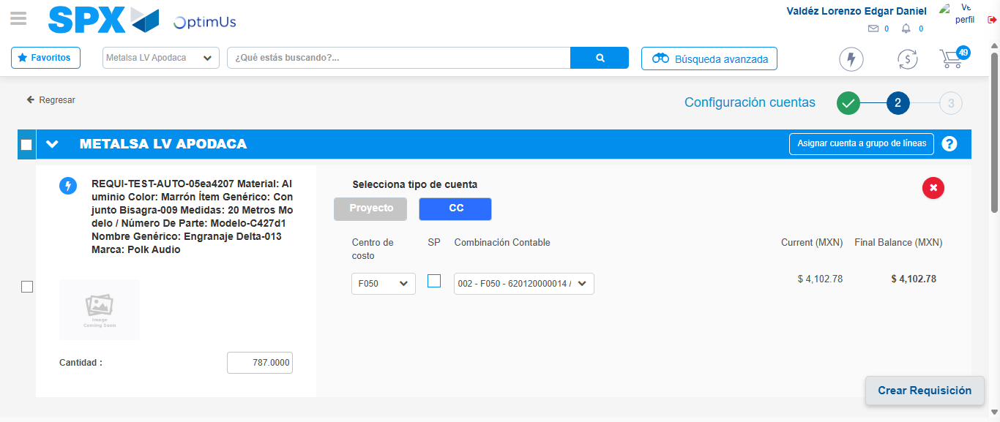Image file-name: QC_Testing-tc001_SPX_Dev5_Crear_Nueva_Linea_Requisicion_Spot_Tipo_Cobro_CC-1781315556167

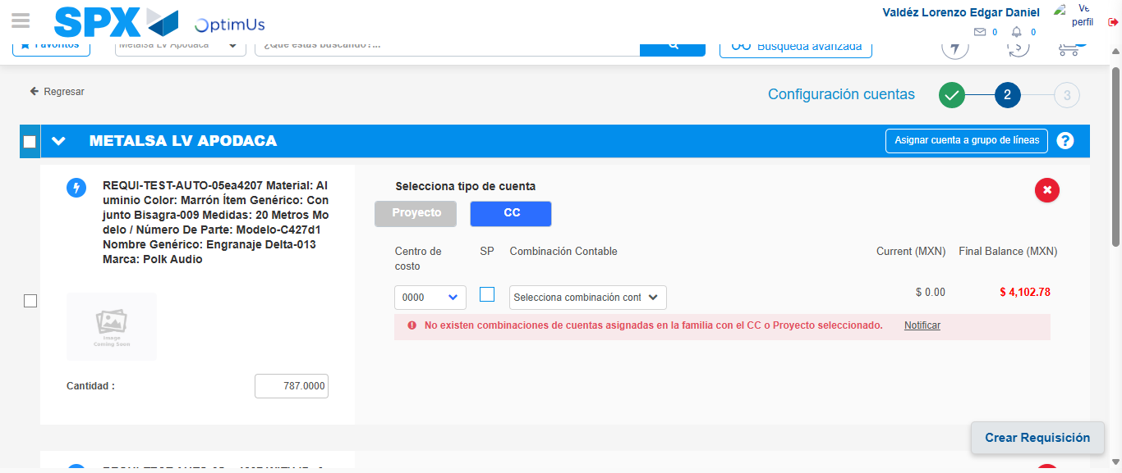Image file-name: QC_Testing-tc001_SPX_Dev5_Crear_Nueva_Linea_Requisicion_Spot_Tipo_Cobro_CC-1781315566856

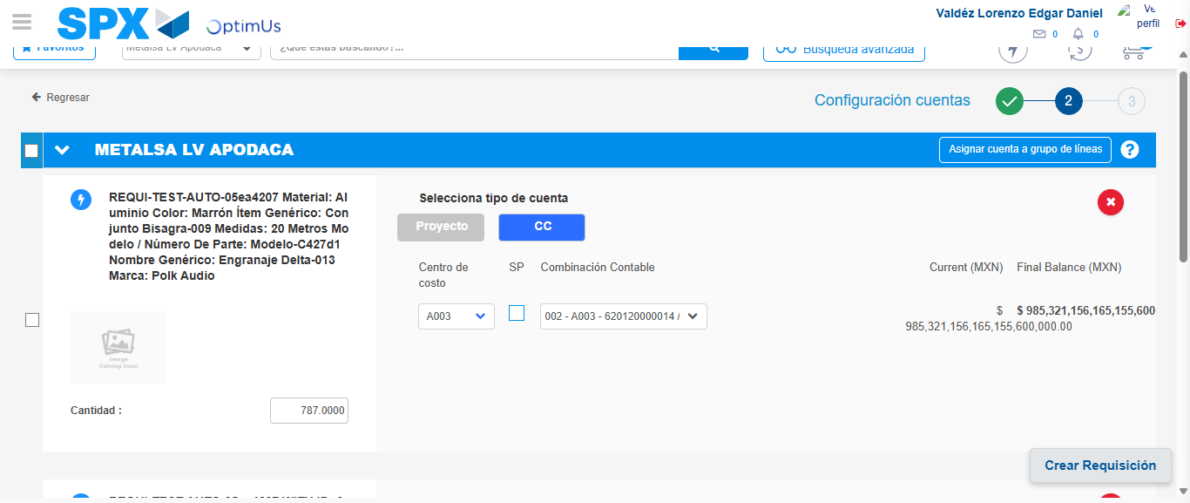Image file-name: QC_Testing-tc001_SPX_Dev5_Crear_Nueva_Linea_Requisicion_Spot_Tipo_Cobro_CC-1781315575015

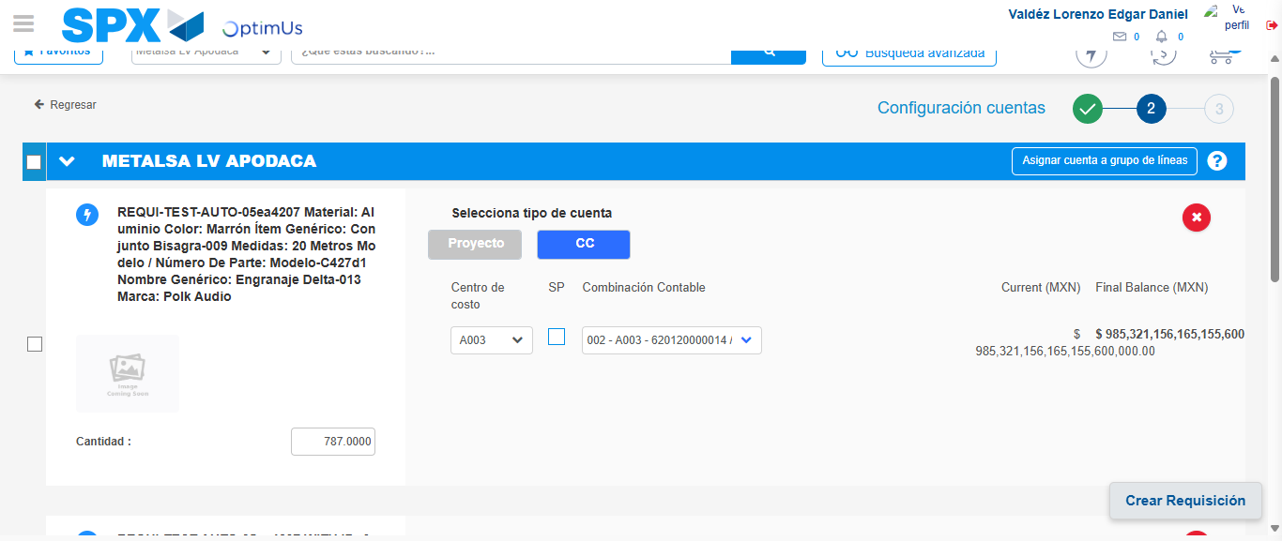Image file-name: QC_Testing-tc001_SPX_Dev5_Crear_Nueva_Linea_Requisicion_Spot_Tipo_Cobro_CC-1781315577651

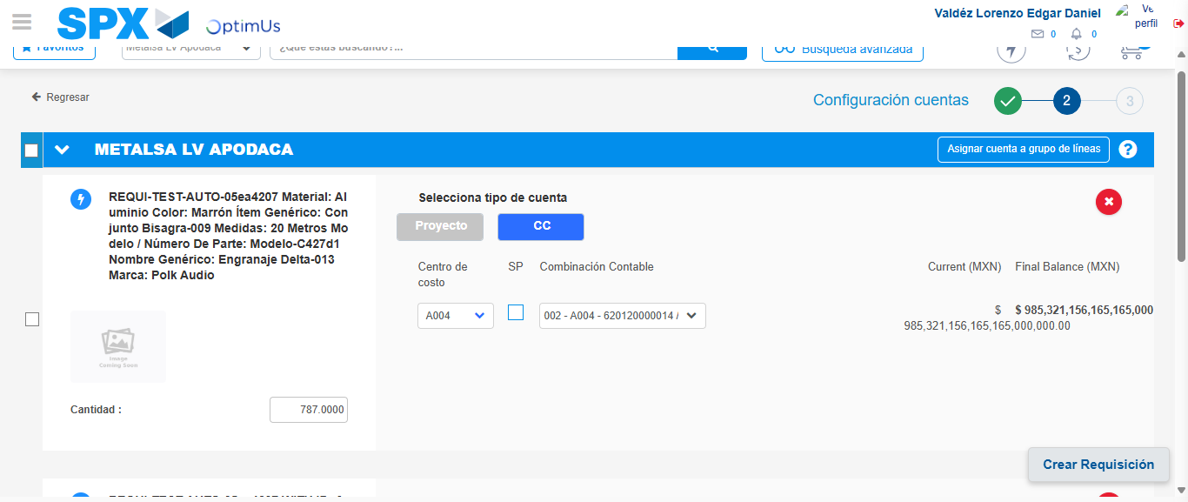Image file-name: QC_Testing-tc001_SPX_Dev5_Crear_Nueva_Linea_Requisicion_Spot_Tipo_Cobro_CC-1781315584814

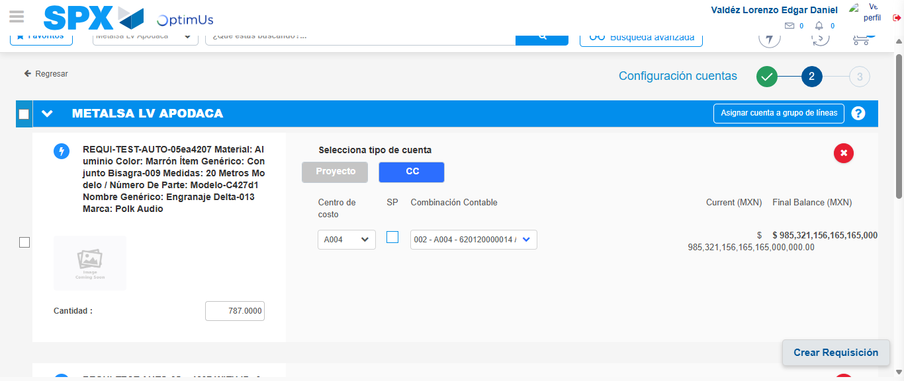Image file-name: QC_Testing-tc001_SPX_Dev5_Crear_Nueva_Linea_Requisicion_Spot_Tipo_Cobro_CC-1781315587426

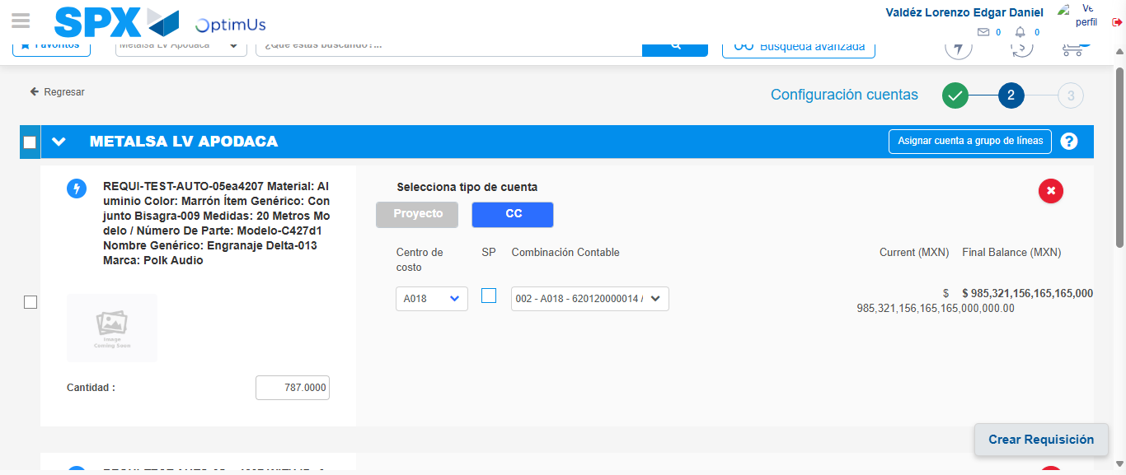Image file-name: QC_Testing-tc001_SPX_Dev5_Crear_Nueva_Linea_Requisicion_Spot_Tipo_Cobro_CC-1781315594682

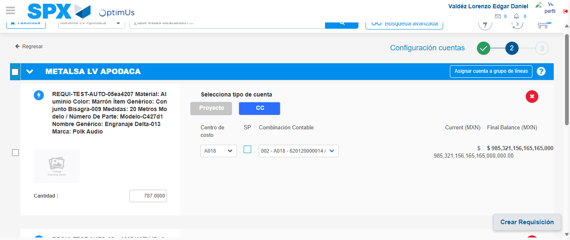Image file-name: QC_Testing-tc001_SPX_Dev5_Crear_Nueva_Linea_Requisicion_Spot_Tipo_Cobro_CC-1781315597511

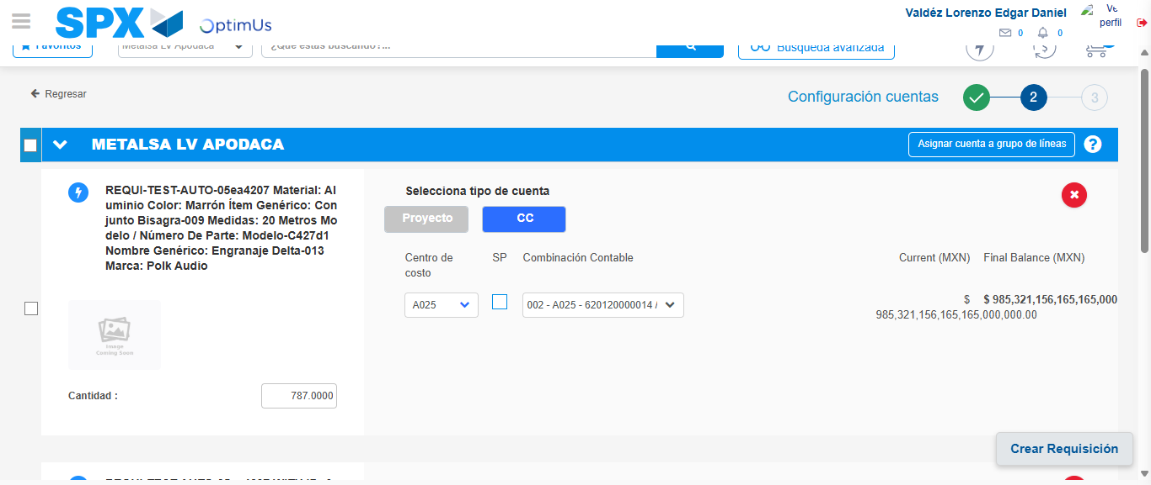Image file-name: QC_Testing-tc001_SPX_Dev5_Crear_Nueva_Linea_Requisicion_Spot_Tipo_Cobro_CC-1781315605208

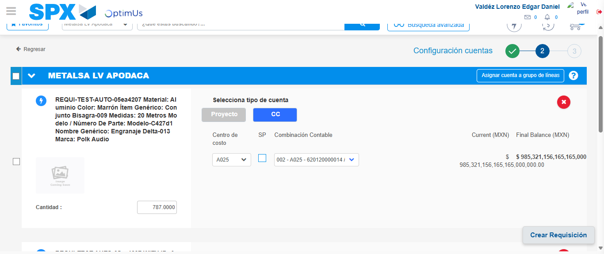Image file-name: QC_Testing-tc001_SPX_Dev5_Crear_Nueva_Linea_Requisicion_Spot_Tipo_Cobro_CC-1781315607926

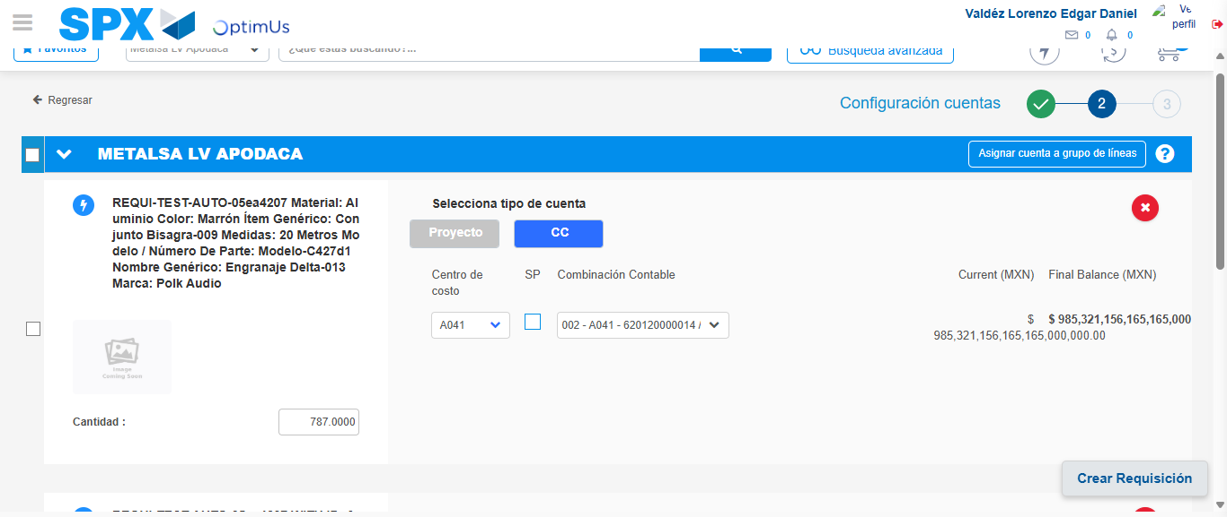Image file-name: QC_Testing-tc001_SPX_Dev5_Crear_Nueva_Linea_Requisicion_Spot_Tipo_Cobro_CC-1781315615651

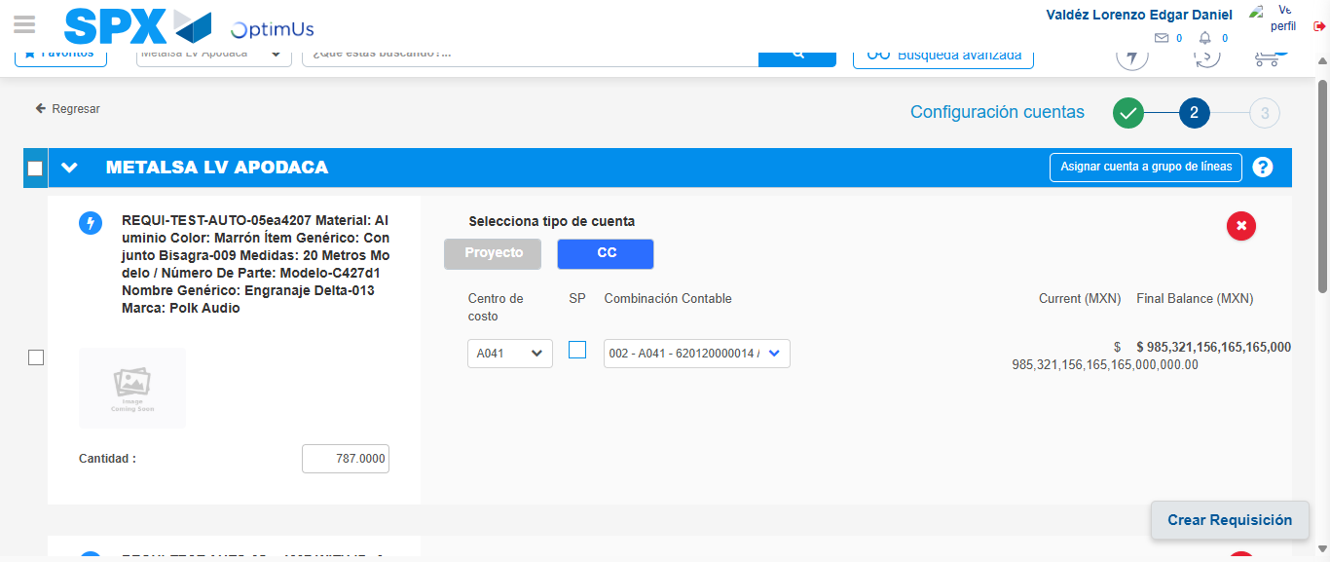Image file-name: QC_Testing-tc001_SPX_Dev5_Crear_Nueva_Linea_Requisicion_Spot_Tipo_Cobro_CC-1781315618458

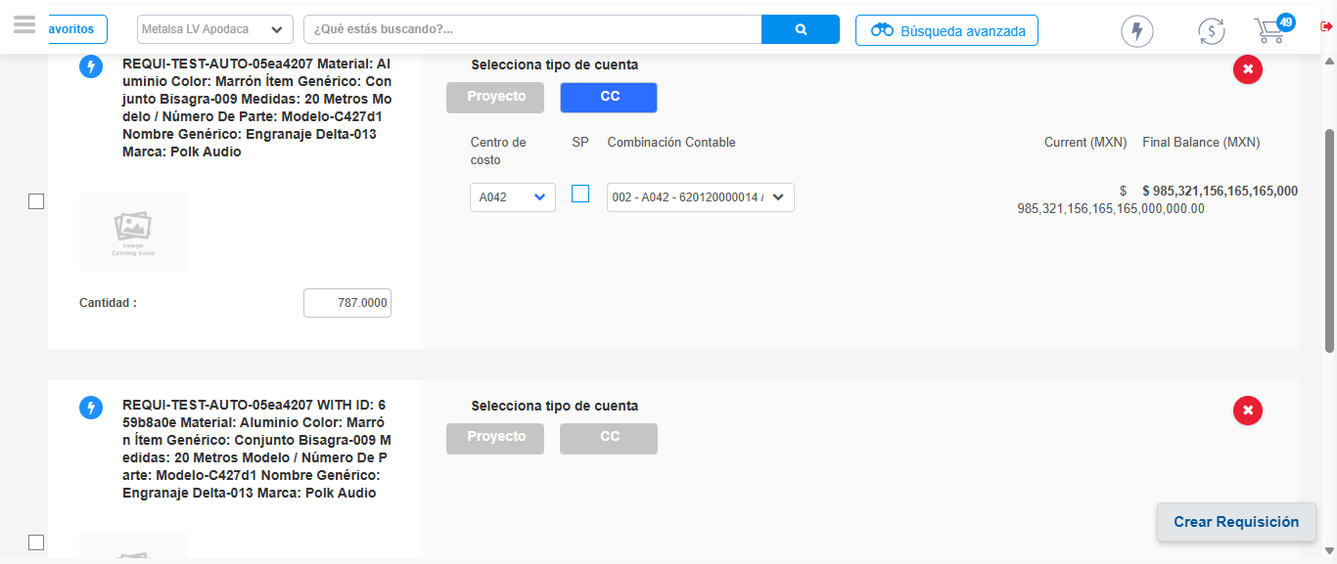Image file-name: QC_Testing-tc001_SPX_Dev5_Crear_Nueva_Linea_Requisicion_Spot_Tipo_Cobro_CC-1781315626174

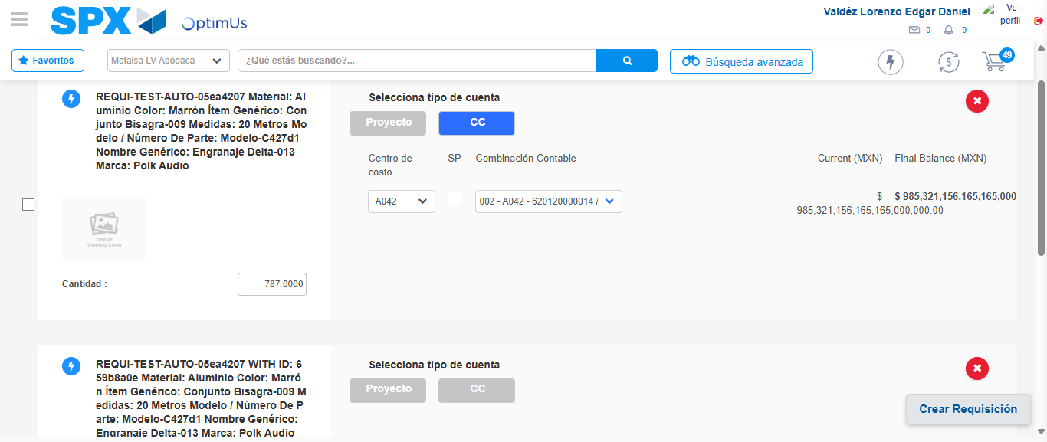Image file-name: QC_Testing-tc001_SPX_Dev5_Crear_Nueva_Linea_Requisicion_Spot_Tipo_Cobro_CC-1781315628842

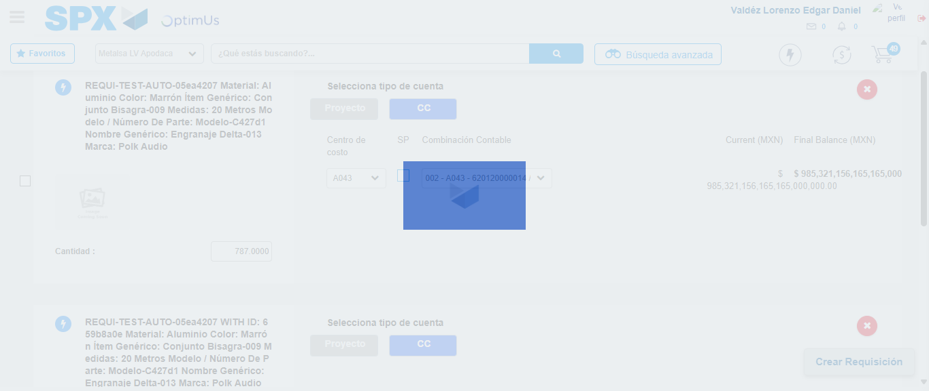Image file-name: QC_Testing-tc001_SPX_Dev5_Crear_Nueva_Linea_Requisicion_Spot_Tipo_Cobro_CC-1781315635977

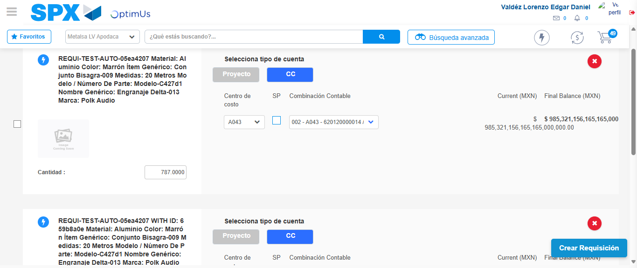Image file-name: QC_Testing-tc001_SPX_Dev5_Crear_Nueva_Linea_Requisicion_Spot_Tipo_Cobro_CC-1781315643582

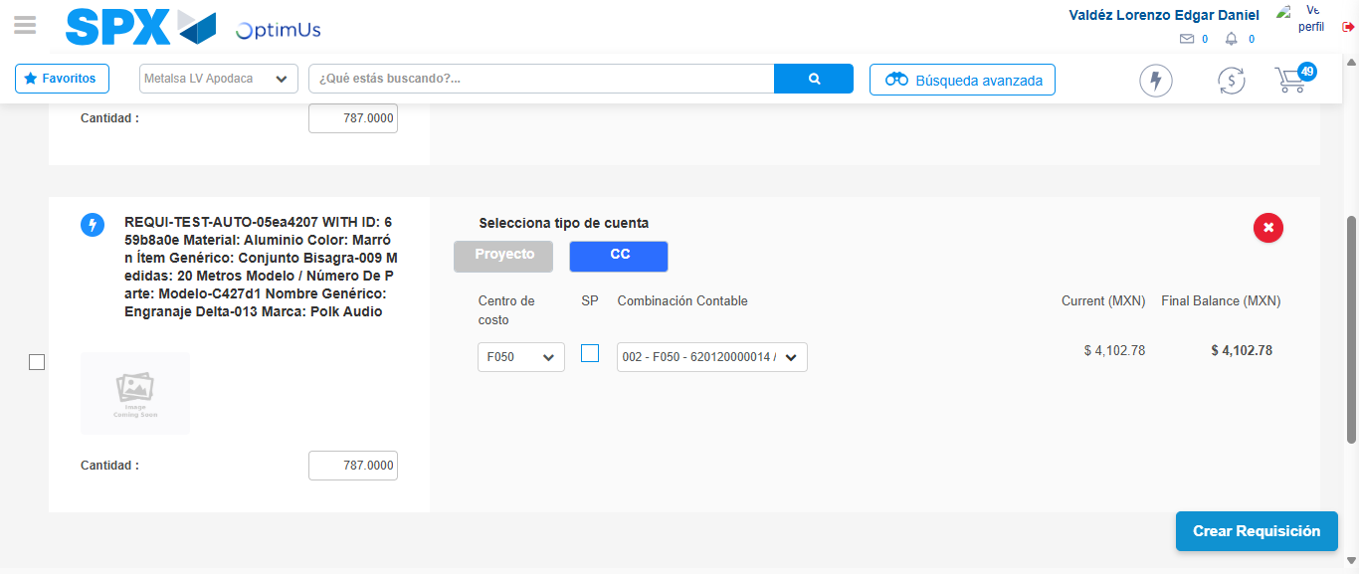Image file-name: QC_Testing-tc001_SPX_Dev5_Crear_Nueva_Linea_Requisicion_Spot_Tipo_Cobro_CC-1781315645861

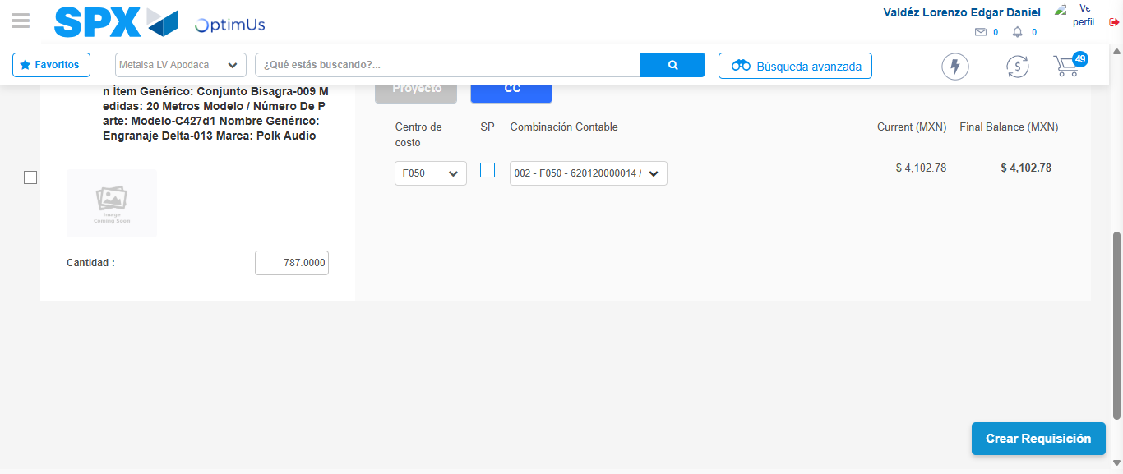Image file-name: QC_Testing-tc001_SPX_Dev5_Crear_Nueva_Linea_Requisicion_Spot_Tipo_Cobro_CC-1781315646040

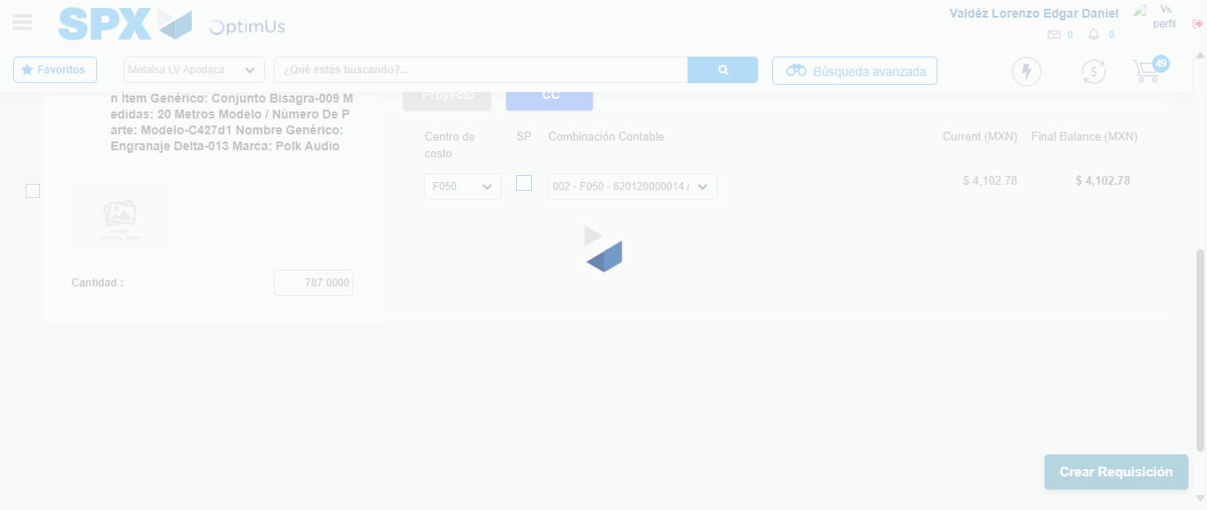Image file-name: QC_Testing-tc001_SPX_Dev5_Crear_Nueva_Linea_Requisicion_Spot_Tipo_Cobro_CC-1781315646362

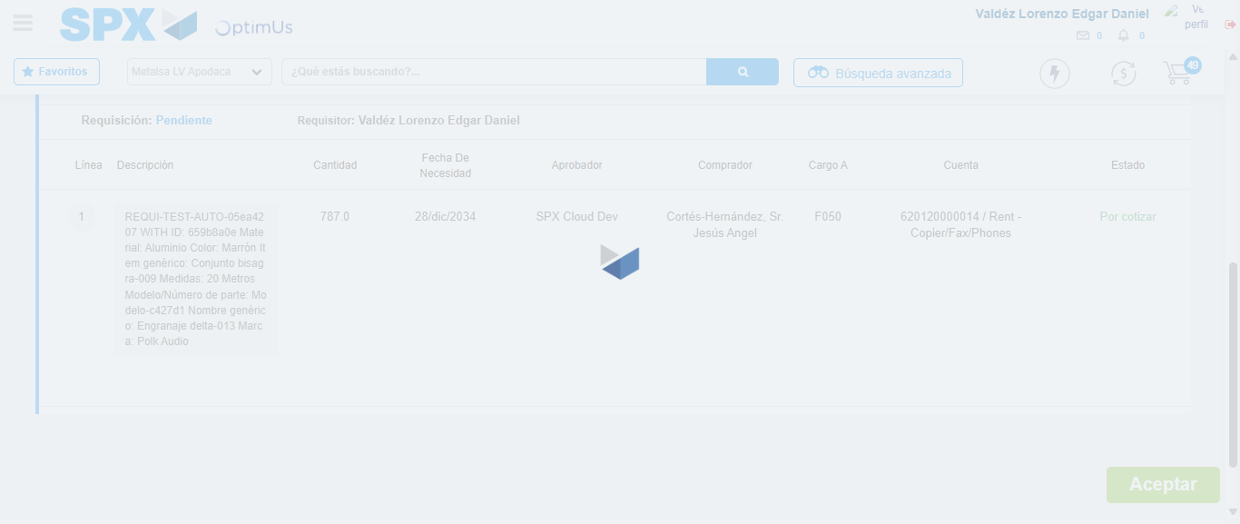Image file-name: QC_Testing-tc001_SPX_Dev5_Crear_Nueva_Linea_Requisicion_Spot_Tipo_Cobro_CC-1781315646551

Step 7 - Accept to Requisition: Requisition Accepted
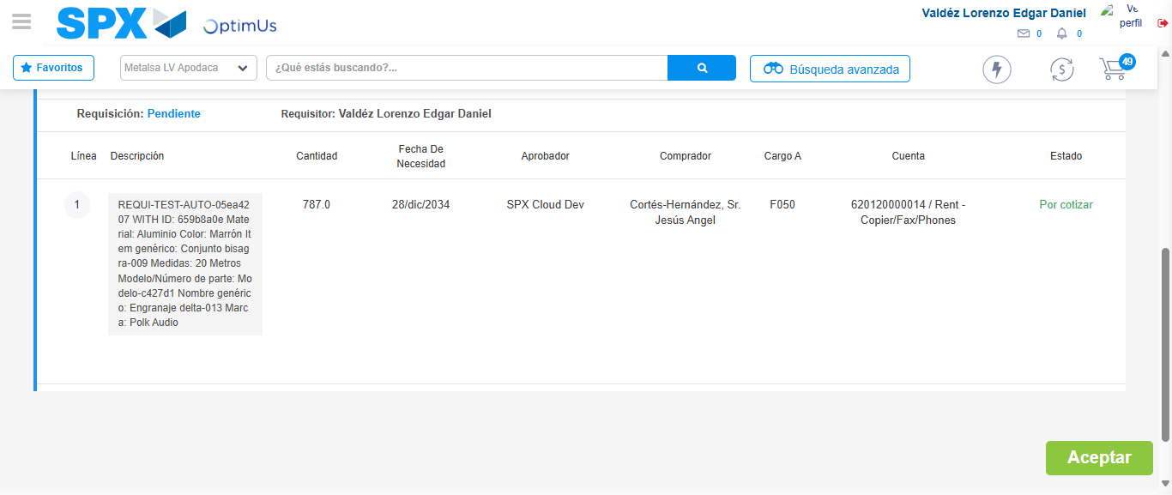Image file-name: QC_Testing-tc001_SPX_Dev5_Crear_Nueva_Linea_Requisicion_Spot_Tipo_Cobro_CC-1781315647256

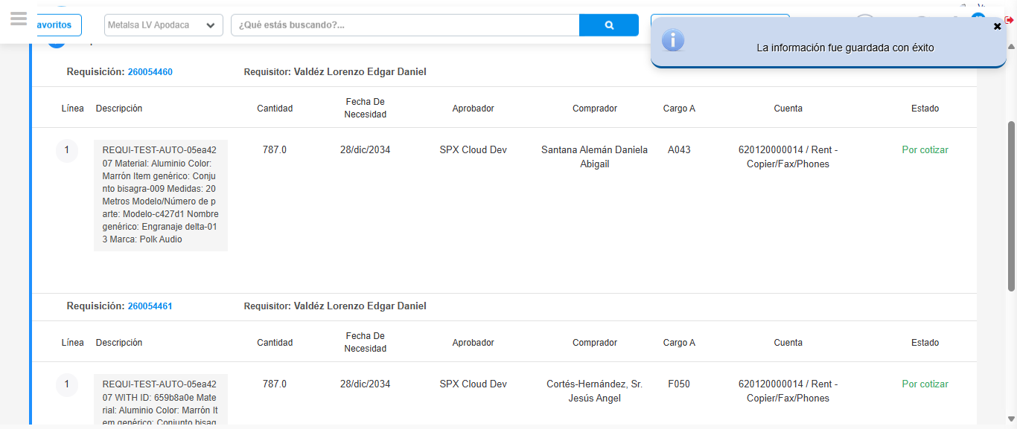Image file-name: QC_Testing-tc001_SPX_Dev5_Crear_Nueva_Linea_Requisicion_Spot_Tipo_Cobro_CC-1781315649693

Step 8 - Return to Main Page SPX : Return to Main Page SPX
Image file-name: QC_Testing-tc001_SPX_Dev5_Crear_Nueva_Linea_Requisicion_Spot_Tipo_Cobro_CC-1781315475385

Image file-name: QC_Testing-tc001_SPX_Dev5_Crear_Nueva_Linea_Requisicion_Spot_Tipo_Cobro_CC-1781315477936

Image file-name: QC_Testing-tc001_SPX_Dev5_Crear_Nueva_Linea_Requisicion_Spot_Tipo_Cobro_CC-1781315500756

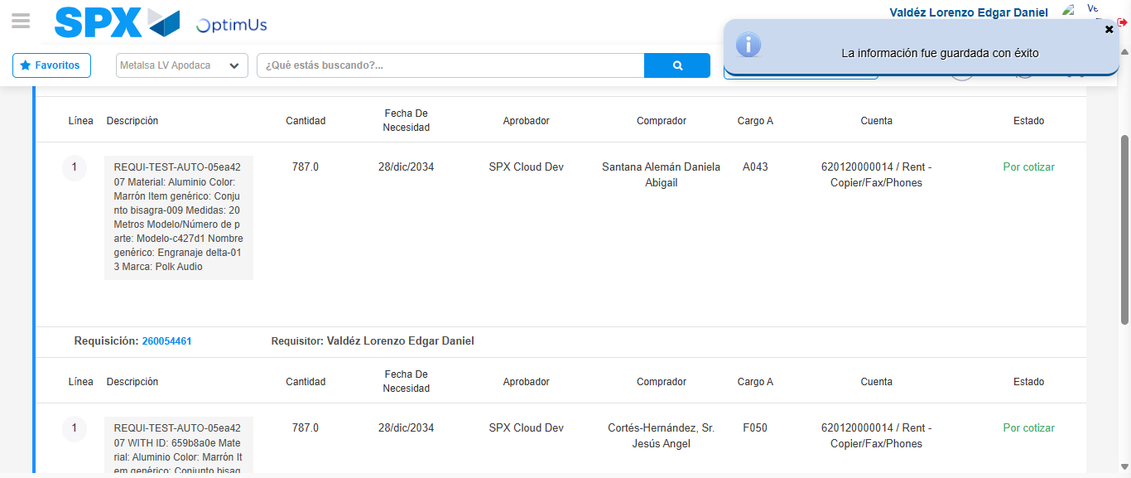Image file-name: QC_Testing-tc001_SPX_Dev5_Crear_Nueva_Linea_Requisicion_Spot_Tipo_Cobro_CC-1781315651942

Image file-name: QC_Testing-tc001_SPX_Dev5_Crear_Nueva_Linea_Requisicion_Spot_Tipo_Cobro_CC-1781315652124

Image file-name: QC_Testing-tc001_SPX_Dev5_Crear_Nueva_Linea_Requisicion_Spot_Tipo_Cobro_CC-1781315673438

Step 9 - Log Out : Log Out SPX
Image file-name: QC_Testing-tc001_SPX_Dev5_Crear_Nueva_Linea_Requisicion_Spot_Tipo_Cobro_CC-1781315673683

